**Pymaceutical Study Report**

Among all ten kinds of drugs we study, only two show significant effect on reducing the size of the tumor: Capomulin and Ramicane. Though we didn’t focus on Ramicane, it clearly has the best result.

Capomulin -19.475303

Ceftamin 42.516492

Infubinol 46.123472

Ketapril 57.028795

Naftisol 53.923347

Placebo 51.297960

Propriva 47.241175

Ramicane -22.320900

Stelasyn 52.085134

Zoniferol 46.579751

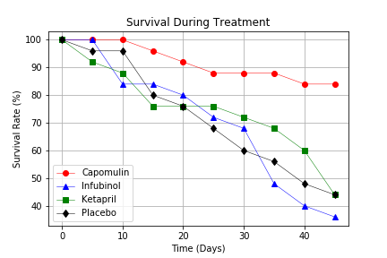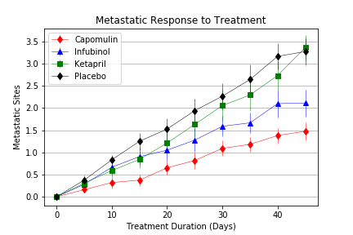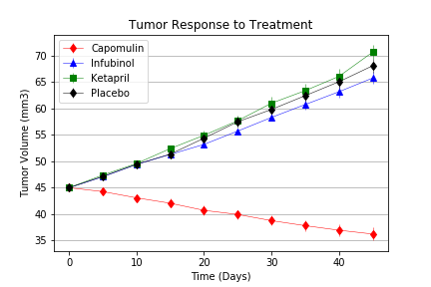For the four drugs we are focusing on, Capomulin is the only one show positive effects on reducing the tumor size and limiting the metastasis of the cancer cell. Mice taking Capomulin have a better chance to survive beyond 45 days.

Besides Ramicane, Capomulin is also the most stable drug that might work for it has the lowest standard errors amongst all drugs. This means our test result on Capomulin is relatively more reliable.

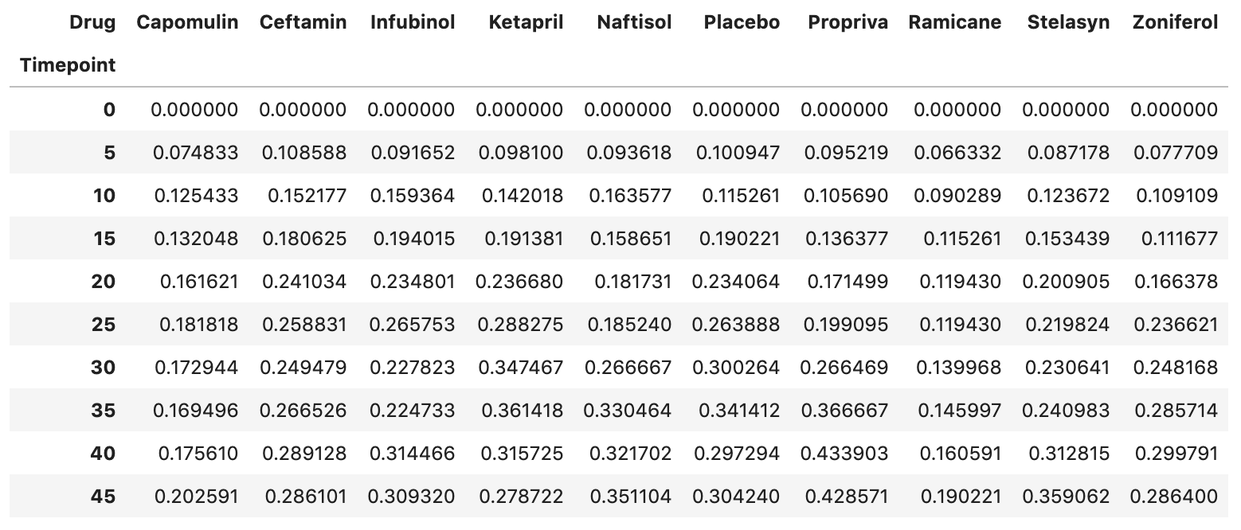

The Standard Error of the Metastatic Sites

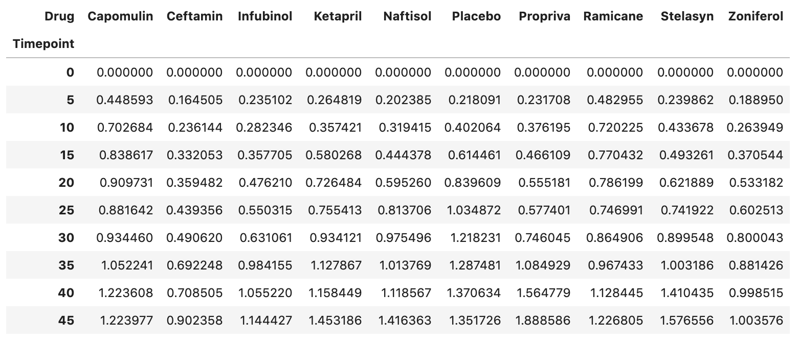

The Standard Error of the Average Tumor Size